Case 10-MEX-Teotihuacan-Incensario Lid--Ceramic- 400-700 CE

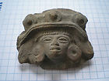

Fig. 1. Teotihuacán-Incensario Lid Fragment, 400-700 CE-Ceramic

**Case no.:**

**Accession Number:**

**Formal Label:** Teotihuacán-Incensario Lid Fragment, 400-700 CE-Ceramic

**Display Description:** This elaborate lid fragment from a ceremonial incensario (incense burner) depicts the head of a Teotihuacán warrior wearing a large headdress and earplugs. Teotihuacan (used for both the entire civilization and the archaeological site) began as a religious center ca 100 CE. A city of multi-floor apartment compounds was built to accommodate a population that reached 150,000 by 500 CE. Its influence was felt throughout Mesoamerica from Veracruz and the Yucatan peninsula. When the invading Aztecs (of Nahua, Otomi or Totonac ethnicities) saw the ruins of the city, they claimed a common lineage. By 500 CE Teotihuacán was one of the largest cities in the world, with an estimated population of 150,000.

This lid fragment represents the prototype of the warrior image from the city of Teotihuacan, an image that was copied by local area potters who were under the influence of Teotihuacán.

**LC Classification:** [F1219.1.T27](http://josiah.brown.edu/search~S7?/cF1219.1.T27+G37+1980/cf++1219.1+t27+g37+1980/-3,-1,,E/browse)

**Date or Time Horizon:** 400-700 CE

Geographical Area: Teotihuacán, 30 mi NE of Mexico City

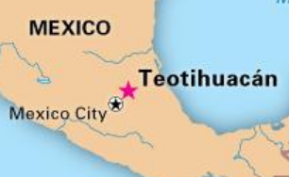

Fig. 2. <http://media-1.web.britannica.com/eb-media/33/19733-004-B8F4AC9B.jpg>

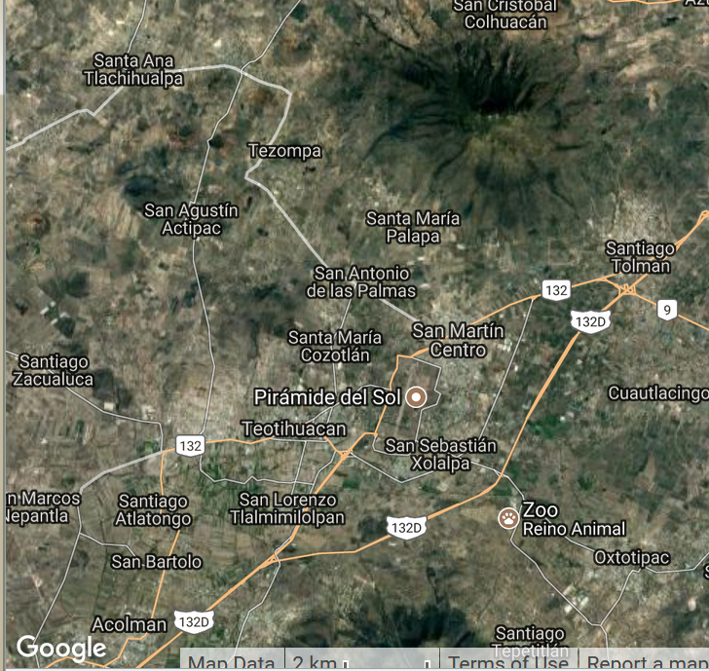

Fig. 3. The archaeological site is located in what is now the San Juan Teotihuacán municipality in the State of México, approximately 40 km (25 mi) northeast of Mexico City. The site covers a total surface area of 83 square km (32 sq mi) and was designated a UNESCO World Heritage Site in 1987. It is the most visited archaeological site in Mexico. Map from Google.

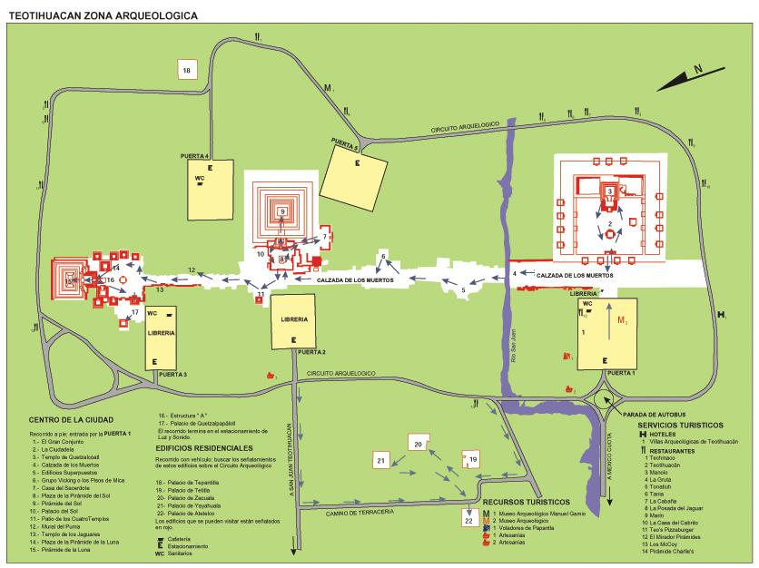

Fig.4. Map of Teotihuacán From http://mapas.owje.com/img/Mapa-Zona-Arqueologica-de-Teotihuacan-Edo-Mexico-8761.jpg

**Map, GPS coordinates:** 19.69044 -98.85695; 40° 26' 46" N 79° 58' 56" W

**Cultural Affiliation:** Teotihuacán

**Medium:** ceramic.

**Dimensions:**

**Weight:**

**Condition:** original

**Provenance:** unknown

**Discussion:**

This lid, found more than seven hundred miles away from Teotihuacan in the Tiquisate Region, Department of Escuintla, Guatemala, represents a local potter’s version of the Teotihuacan prototype that is illustrated in our example. The following is the Brooklyn Museum’s description of it from Brooklyn Museum n.d.:

Elaborate incensario or incense burner lid in the form of a male bust wearing a spectacular headdress with three discs, two feathered quetzal eyes and three bundles of spear ends. The figure wears large circular ear spools and a removable trapazoidal talud-tablero style nose ornament. He carries a blade-like object in the left hand and a bundle of spear ends in the right, suggesting a warrior figure. White, buff, yellow, ochre and red paint are still visible throughout the piece. Teotihuacan-style incense burners usually consist of two basic sections: an hourglass-shaped base (missing) and an elaborate chimney lid. Incense burners from Escuintla, Guatemala generally have unadorned bases and elaborate lids. The presence of Teotihuacan-style incensarios on Guatemala's Pacific coast (about 700 miles away from the Valley of Mexico), attest to the success of Teotihuacan expansion throughout Central America. The original molds for the decorative elements were probably brought south from Central Mexico, but assembled in a local manner typical of Escuintla.

[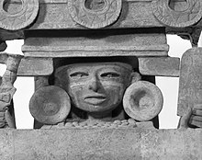](https://en.wikipedia.org/wiki/File:Incensario_Lid,Teotihuacan_style,_400-700_C.E.,75.148.jpg)

Fig. 5. Teotihuacan style warrior image from an incensario lid, 400-700 CE. Detail. (Photo: Brooklyn Museum, 75.148_bw.jpg).

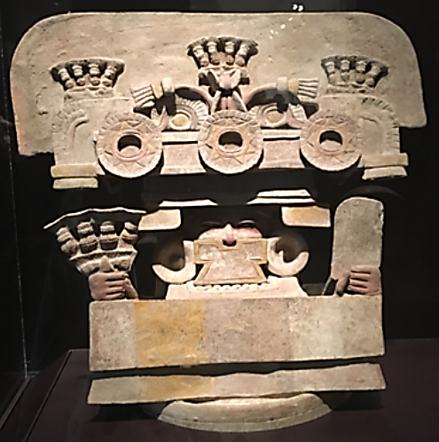

Fig. 6. Teotihuacan style warrior image from an incensario lid, 400-700 CE in original position but obscured by poor lighting. Ceramic, pigment, 18 1/8 x 19 1/2 x 9 1/4in. (46 x 49.5 x 23.5cm). Brooklyn Museum, Gift of Mr. and Mrs. Richard Danziger, 75.148. From https://encrypted-tbn0.gstatic.com/images?q=tbn:ANd9GcQK-YDveuCWVjrfu28CGcjOJFvFFjGOO7kJZXxljM1PkRBcX5VO

**References:**

Brooklyn Museum. N.d. From https://www.brooklynmuseum.org/opencollection/objects/1542

Cowgill, George L. 2015. *Ancient Teotihuacan: early urbanism in Central Mexico*. New York, NY: Cambridge University Press

García Valadés, Adrián. 1980. *Teotihuacan: the city of the gods*. Mexico City: Orto

**AP:** .7